Unit 8: Quadratics

Lesson 6: Solving Quadratics all different ways algebraically

Objectives:

* I can identify the roots of a cubic function looking at the graph.
* I can identify the factors of a cubic function looking at the graph.
* I can graph quadratic functions.
* I can identify the x-intercepts, y-intercept, and vertex.

Agenda:

* Quiz
* Applications

Focus Questions:

* What are the roots of a cube function?
* How do we calculate the zeros and vertex using the calculator?
* How do we solve real life quadratics algebraically?

Vocabulary:

Quadratic function, cube function, Parabola, Vertex, Roots

Homework: HW 8-6

Web support:

* <https://www.youtube.com/watch?v=DUKwp_V4_8g>
* <https://www.youtube.com/watch?v=ztPc80kzdg0>
* <https://www.youtube.com/watch?v=Iva5GFghJoE>

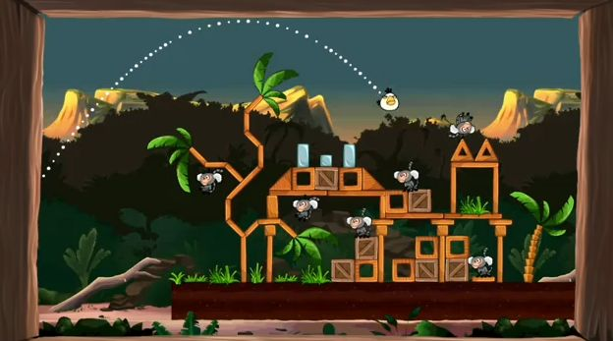

**Do Now**

Solve the following Quadratic equations by taking square root:

2 3.

4. Solve by completing the square. $x^{2}+6x+4=0$



$5. x^{2}+8x+15=0$ 6. $x^{2}+11x+10=0$

**Notes: How to write quadratics from graphs:**

**For the graphs below, find the roots for each and a possible equation for each.**

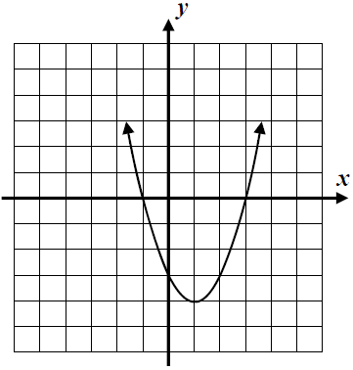

* **List the roots:**
* **Work backwards and make them factors**
* **Distribute for a possible quadratic equation in the standard form:**

Your turn:

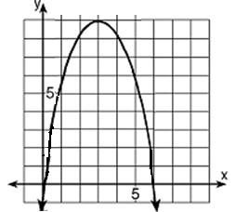

* **List the roots:**
* **Work backwards and make them factors**
* **Distribute for a possible quadratic equation in the standard form:**

**Cube functions**

1. 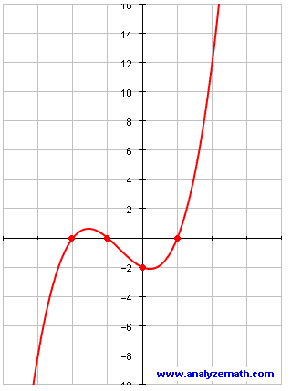Which function is represented by graph:
$f\left(x\right)=(x+1)\left(x-1\right)(x-2)$

$f\left(x\right)=(x-1)\left(x+1\right)(x+2)$

$f\left(x\right)=-(x-1)\left(x+1\right)(x+2)$

$f\left(x\right)=-(x+1)\left(x-1\right)(x-2)$

2. Put the function in the standard form.

2 a. Identify the roots for the graphed cube function:

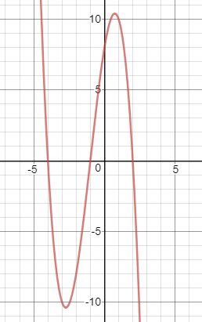

1. Which function is represented by graph:

$f\left(x\right)=\left(x-4\right)\left(x-1\right)\left(x+2\right)$

$f\left(x\right)=\left(x+4\right)\left(x+1\right)\left(x-2\right)$

$f\left(x\right)=-\left(x-4\right)\left(x-1\right)\left(x+2\right)$

$f\left(x\right)=-(x+4)\left(x+1\right)(x-2)$

1. Put the function in the standard form.

3) Given the cubic function: $f\left(x\right)=x^{3}+{4x}^{2}-12x$. Factor the cubic function.

**How about some word problems:**

1. The product of two consecutive, positive odd integers is 63.
2. Write an equation that can be used to find the integers.
3. Solve the equation to find the integers

**Your turn:**

The width of a rectangle is 6 less than the Length. The area of the rectangle is 55. Find the dimensions of the rectangle.

1. Write an equation that can be used to find the dimensions of the window?
2. Solve algebraically

Name: _______________ Date: __________ **Homework 8-6**

1. A slow pitch softball is pitched to a batter. The ball follows a path in which the height in feet, *h*, is given by $h = -2t^{2} + 8t + 3$, where *t* is the time in seconds elapsed since the ball was pitched.

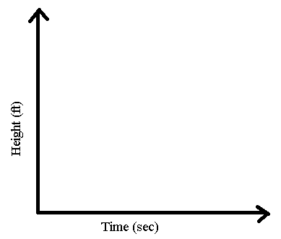(a) Sketch the graph Using an appropriate window.

(b) At what height was the ball released from the pitcher's hand?

1. Calculate the time (t) it will take the ball to hit the ground graphically.
2. The product of two consecutive even negative integers is 48. Find the integers
3. Write an equation that can be used to find the integers.
4. Solve the equation to find the integers
5. A) Identify the roots for the graphed cube function:

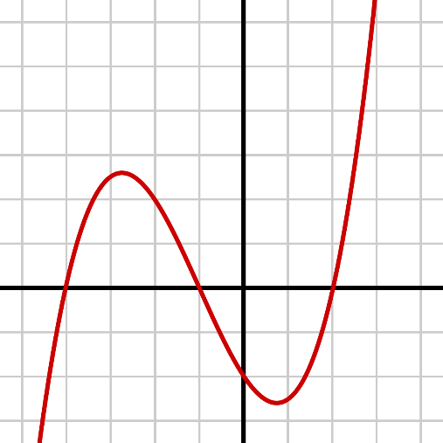

1. Which function is represented by graph:

$f\left(x\right)=\left(x-4\right)\left(x-1\right)\left(x+2\right)$

$f\left(x\right)=\left(x+4\right)\left(x+1\right)\left(x-2\right)$

$f\left(x\right)=\frac{1}{4}\left(x-4\right)\left(x-1\right)\left(x+2\right)$

$f\left(x\right)=\frac{1}{4}(x+4)\left(x+1\right)(x-2)$